

Department of Artificial Intelligence & Data Science Engineering

Academic Year 2022-23

Crime Detection Analysis

Shubham Agarwal- 1

**INDEX**

**Sr.**

**No.**

**Contents**

**Page No.**

1. Introduction 3

2. Problem statement

4

3. Project Objectives

4

4. Literature Survey

5

1. Summary/ Finding of Literature Survey
2. Gantt Chart

6

7. Proposed system

7

8. Software /Hardware requirement

7

9. System design

8

1. System implementation
2. Results
3. Conclusion
4. Future Scope
5. References

# INTRODUCTION

Our goal is to eradicate crime from our society. For the most part, the crime investigation start after a complaint has been filed, after the crime has already occurred. Such a system is good for fighting crime, but the key to decrease the crime rates would be crime avoidance. Our goal is to use technology and computer science to offer crime prevention. Clustering algorithms can help determine crime prone areas based on the history of criminal incidences. With such an application, anti-crime organizations will have strong knowledge about the crime prone areas, types of crime that may happen and the parties that might involve

The objective of this project is to analyse dataset which consist of numerous crimes and predicting the type of crime which may happen in future depending upon various conditions. In this project, we will be using the technique of machine learning and data science for crime prediction of crime data set. It consists of crime information like location description, type of crime, date, time, latitude, longitude. Before training of the model data pre-processing will be done following this feature selection and scaling will be done so that accuracy obtain will be high.

Crime analysis provides a process, which incorporates crime into site analysis.1 The analysis is sometimes called a safety audit or risk assessment. This process has been developed based on a variety of neighborhoods and sites and in particular areas ranging from neighborhood developments, transit stations, mega-block developments, park designs, public realm plazas, and corporate/business operations.

* Crime scene analysis (crime analysis) is the analytical process of interpreting the specific features of a crime and related crime scenes.
* It involves an integrated assessment of the forensic evidence, forensic victimology, and crime scene characteristics.
* The results of crime scene analysis (CSA) may be used to determine the limits of the available evidence and the need for additional investigative and forensic efforts, as in a threshold assessment

**PROBLEM STATEMENT**

The purpose of this project is to give a idea of how machine learning can be used by the law enforcement agencies to detect, predict and solve crimes at a much faster rate and thus reduces the crime rate. We will be using the technique of machine learning and data science for crime prediction of crime data set. It consists of crime information like location description, type of crime, date, time, latitude, longitude

# OBJECTIVES

The objective of the most crime analysis is to find meaningful information in vast amounts of data and disseminate this information to officers and investigators in the field to assist in their efforts to apprehend criminals and suppress criminal activity

The objectives constitute a major element in crime analysis. Among the various objectives, the main objective is to apprehend criminals. It is due to the fact that the primary function of law enforcement agencies in the apprehension of criminals and it can be executed to a greater extent through crime analysis. For this purpose, the quantitative data like date and time of the commission of a crime and the qualitative data like victim credentials will help the agencies in getting hold of the perpetrator of an offence.

The second major objective of crime analysis is the prevention or curtailment of crime. The information collected and processed by crime analysis essentially provides a mechanism to prevent or curtail crimes. For instance, the data of the neighborhood being involved in the majority of the crimes facilitates law enforcement agencies to concentrate on the movements of offenders living there or to create awareness among them thus enabling the curtailment of crimes to a larger extent

# LITERATURE SURVEY

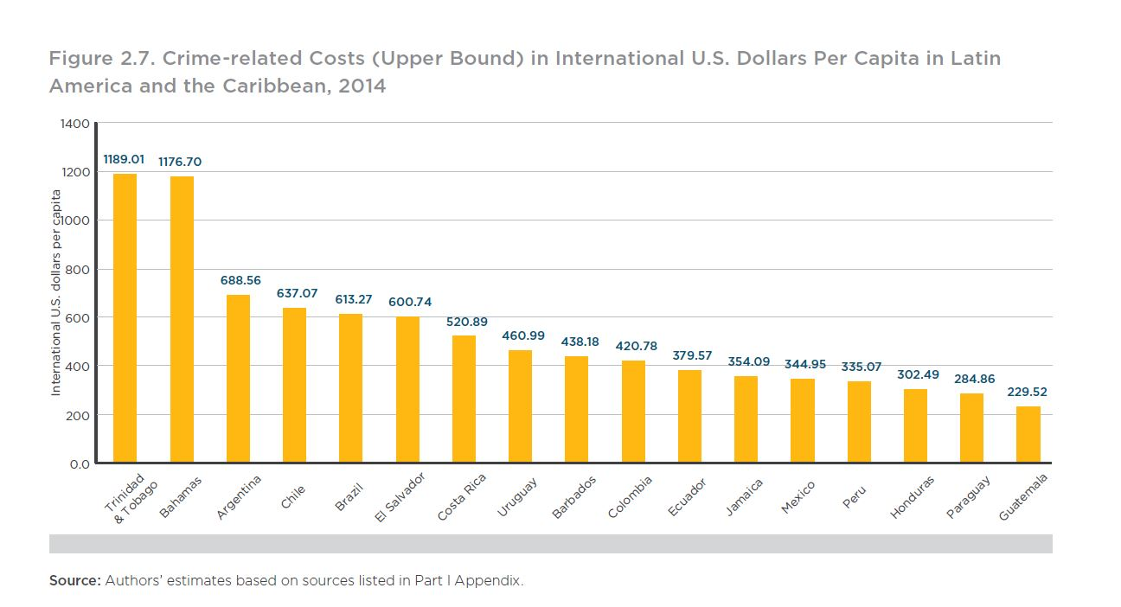

In the past, there have been many such systems, where crime data is analysed using different algorithms, mainly K-Means, K-Medoids, KNN etc. Some of the models and methodology are explained: The authors, Jain et al. in their paper “Crime Prediction using K-Means Algorithm” [2], have used K-means clustering algorithm to find out patterns from the crime dataset. K-Means clustering algorithm is distance based algorithm. The Euclidean distance metric is used to find the distance of a point from the nearest centres and decides if that point should belong to the cluster or not. The number of clusters cannot be determined at the start of the algorithm. Hence various iterations of K-Means have to be performed. The authors have used Rapid Miner tool for analysis because of its flexibility and scalability. The main aim of the analysis was to understand which year was the crime rate highest and lowest. Supporting this information, bar graphs are plotted for each cluster.

Google maps representation is done to show the clusters over a map. However, the representation is not useful enough, since only markers over the map give information about the number of crimes took place in a vast area around the marker, not giving much information about the exact location of crime.

# GANTT CHART

# 

**PROPOSED SYSTEM**

. Crime datasets have a huge scope for data mining too. Hidden factors that might support criminals, such as lack of CCTV cameras in an area, absence of street lights, etc. may be highlighted due to information mining. Dealing with such factors will make executing crimes nearly impossible, thus promoting better safety. Such information will clearly define where the anti-crime agencies need to work upon.

Our goal is to eradicate crime from our society. For the most part, the crime investigation start after a complaint has been filed, after the crime has already occurred. Such a system is good for fighting crime, but the key to decrease the crime rates would be crime avoidance. Our goal is to use technology and computer science to offer crime prevention. Clustering algorithms can help determine crime prone areas based on the history of criminal incidences. With such an application, anti-crime organizations will have strong knowledge about the crime prone areas, types of crime that may happen and the parties that might involve

# HARDWARE/SOFTWARE REQUIREMENTS

## Hardware Requirement

* i3 processor system or higher
* 4 GB RAM or higher
* 100 GB ROM or higher

## Software Requirement

* Windows 7 or higher
* Visual Studio Code
* MySQL or any other Database Management System

# SYSTEM DESIGN

1. **Server End and Database**: In the beginning, we have prepared an Entity Relationship diagram (ER) database recipient as per the requirement of the portal & then uses the database on the MYSQL server interface with sufficient security barriers to prevent the external unauthorized access. For privacy & security of our portal, we used two distinct credentials (administrator and user) so that any other person cannot access or update the existing control panel configuration. The control panel verifies the delivery of the program from the user record and keeps the entire system regulated & up to date.
2. **Security Features**: All the users are required to register first, to access the portal services and then the registration would be successful only after verifying & validating the necessary details & the required information. We have used the traditional authentication that authorizes a strong user encrypted password which is verified by the email id with an encrypted quote. Session authentication based user login and access will be validated until the existing user will log out from the portal or the system is unavoidably removed after the exact time the session is over. Therefore, to enable these kinds of major security features, we attempt to make our web portal more reliable & secure for the existing users. We have also used the input validation for the better and genuine registrations, like no one can enter the email address without using any domain name or no one can enter his contact number in less than 10 digits.

**3. User Interface**: In our web portal, secure access is provided to customize user information where the content of the portal varies according to user standards . The portal will display the content as per the login information whether the user is Police or Detective. It has the compatibility of certain devices and browsers in a user-friendly method to make it easier to access the real user.

**SYSTEM DESIGN**

# 

# figure 1

**SYSTEM IMPLEMENTATION**

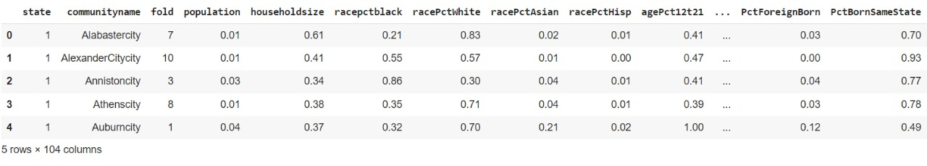

# 

# 

# 

# 

# 

# 

# 

# 

# CONCLUSION

With the help of machine learning technology, it has become easy to find out relation and patterns among various data. The work in this project mainly revolves around predicting the type of crime which may happen if we know the location of where it has occurred. Using the concept of machine learning we have built a model using training data set that have undergone data cleaning and data transformation. The model predicts the type of crime with accuracy of 0.789. Data visualization helps in analysis of data set. The graphs include bar, pie, line and scatter graphs each having its own characteristics. We generated many graphs and found interesting statistics that helped in understanding Chicago crimes datasets that can help in capturing the factors that can help in keeping society safe. The colour represents the type or category of crime and opacity indicates the occurrence of the same. The gray scale regions are crime free. The predictions seem reasonable as they include all different types of crimes ranging from assaults to cyber frauds and match the general pattern of recorded crime

The accuracy values obtained across the three datasets were reasonable within the noisy nature of the dataset and comparable with other similar studies. This allows us to deem the method and approach a reasonably successful one. There are a lot of clustering algorithms and none are perfect. Each has its own advantages and disadvantages. No single algorithm can work for every application We have done crime analysis and the results are plotted on the map, which will not only help us understand the crime trends, but also apply this knowledge directly for helping the users.

# FUTURE SCOPE

This paper presents the visualization techniques and classification algorithms that can be used for predicting the crimes and helps the law agencies. In future, there is a plan for applying other classification algorithms on the crime data and improving the accuracy in prediction. On other direction, we will be trying to build an Android App for the live capture of the realistic data and updating the results by using this new data frequently, that will be helpful in better prediction and providing the general information to the public for the awareness of trends in the crime.

# REFERENCES

1. 1. Yadav, S., Timbadia, M., Yadav, A., Vishwakarma, R., & Yadav, N. (2017, April). Crime pattern detection, analysis & prediction. In Electronics, Communication and AerospaceTechnology (ICECA), 2017 International conference of (Vol. 1, pp. 225- 230). IEEE.
2. 2. Shamsuddin, N. H. M., Ali, N. A., & Alwee, R. (2017, May). An overview on crime prediction methods. In Student Project Conference (ICT-ISPC), 2017 6th ICT International (pp. 1-5). IEEE
3. . 3. Sivaranjani, S., Sivakumari, S., & Aasha, M. (2016, October). Crime prediction and forecasting in Tamilnadu using clustering approaches. In Emerging Technological Trends (ICETT)
4. Ester, Martin; Kriegel, Hans-Peter; Sander, Jörg; Xu, Xiaowei (1996). Simoudis, Evangelos; Han, Jiawei; Fayyad, Usama M. (eds.). A density-based algorithm for discovering clusters in large spatial databases with noise. Proceedings of the Second International Conference on Knowledge Discovery and Data Mining (KDD-96).

# 

# 